Andres E. Lopez

DIG2783

Game Research – HUD

Game #1: Need for Speed Unbound

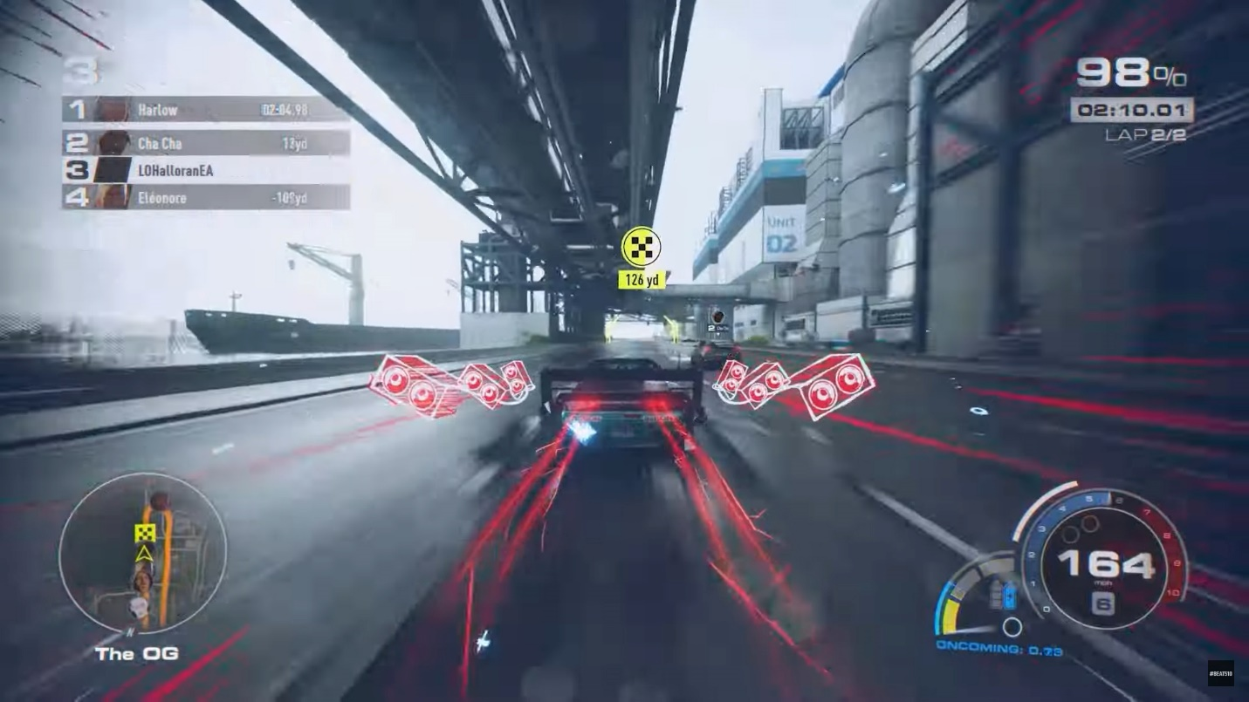

Need for speed unbound features a simple, yet quite unique take on the racing game HUD style. To begin with, it has all the things that racing games usually have; a speedometer on the bottom right along with gears, laps and/or progress on the top right, position on the top left, and the map/track on the bottom left. Unique to Need for Speed unbound there is NOS/boost on the bottom right(blue bar), as well as the unique mechanic of burst NOS(yellow bars) which is earned by near misses, drifts, and other things. Additionally, there are character portraits on the bottom left, above the cars, and on the bottom right, which in my opinion adds that extra bit of charm that sets it apart from other racing games.

Game #2: Mirrors Edge Catalyst

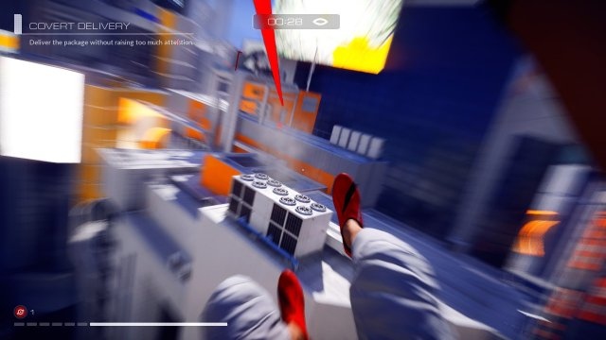

In this game, less is more, and honestly, it fits the game perfectly. This game tries to immerse you into its urban playground, as it throws as little amount of HUD at you as possible. The game only shows your “focus” meter (white bar on the bottom left) which shows how fast you’re going and thus allows you to dodge attacks and do certain movements at certain speeds, your health (grey dashes on the bottom left), your current mission, and your destination. The rest is either hidden or not needed, and it overall makes the game a wonderful experience whether you are running, or just taking a breather and observing the city’s beauty.

Game #3: Overwatch 2

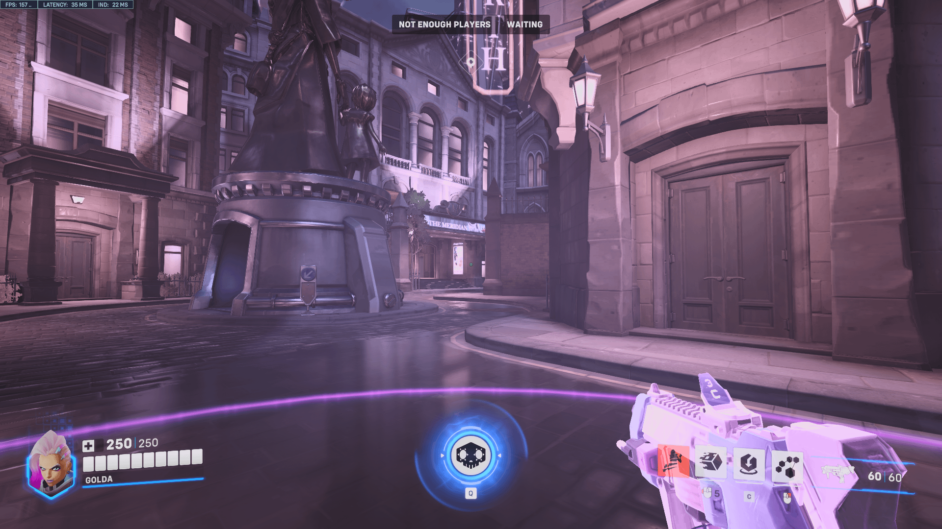

Overwatch 2 is a game that unlike its gameplay, has a very good and non-cluttered HUD. It shows what every class-based FPS game shows you, and does it well. The game shows your weapon and ammo on the bottom right, your abilities and their cooldowns when used right beside it. Additionally on the bottom left it shows your characters portrait based on what skin you are using. Finally, at the bottom center of your screen it shows your ultimate ability, which shows the percentage towards the ability, or shows the charged version when it is fully charged. Depending on the game mode, the HUD will also show the direction where the objective is. Overall, I think that the game does a good job at showing what needs to be shown with as little amount of clutter as possible.

Game #4: World of Warcraft

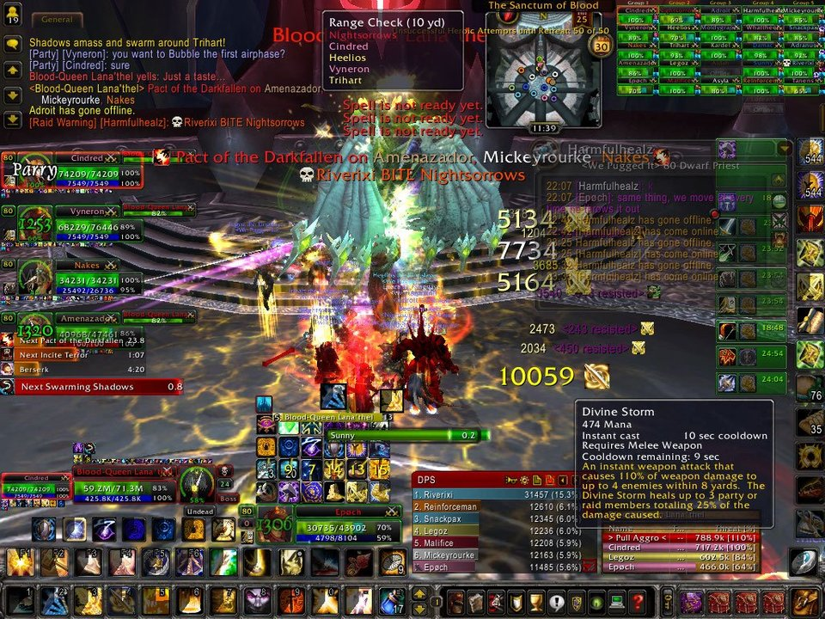

World of Warcraft is a game that I cannot talk positively about when it comes to HUD. As you can see, there are many things on the screen, and to the games defense it is due to the fact that the game is quite old, and the game needs to show you many things. That being said, many of these things can be condensed to have less clutter, mainly the buffs/debugs that you can see on the bottom and right of your screen. Otherwise, the chat (top left) party (left), and abilities (bottom) aren’t entirely the worst. The placement of things aren’t the worst, it’s just the amount of things and the lack of condensing that the game does that brings the problems that I have with this games HUD.